**AI ASSISTED CODING**

**Task Description#1**

* **Use Copilot to generate a is_prime() python function.**

**Expected Output#1**

* **Correct examples verify it True or False**

**Question**

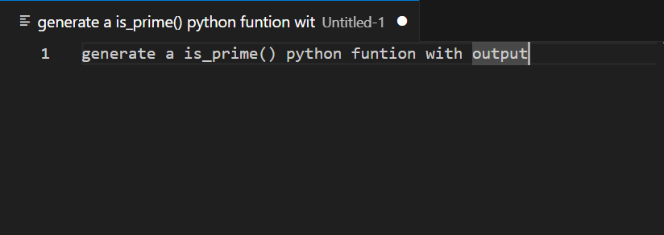

**Code**

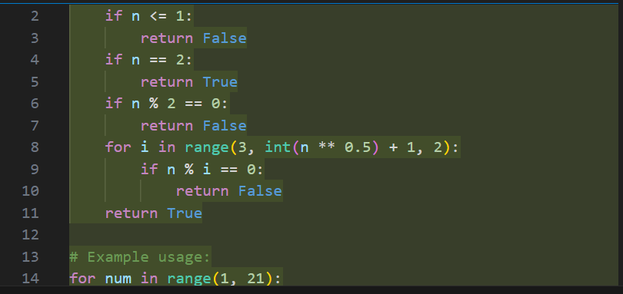

**Output**

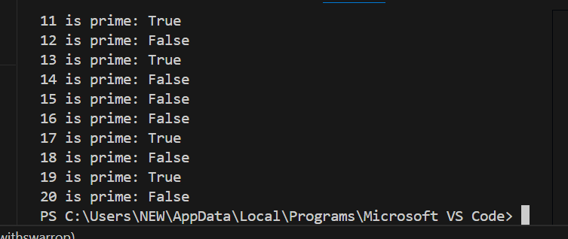

**Task Description#2**

* **Generate a python program for Reverse of a string by using copilot.**

**Expected Output#2**

* **Verify the correct output by giving the reverse string as input**

**Question**

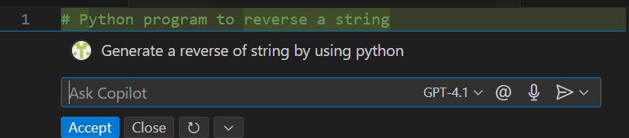

**Code**

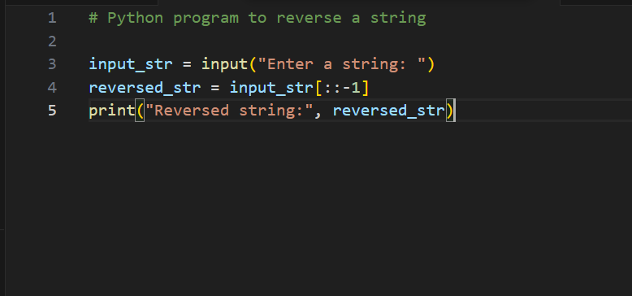

**Output**

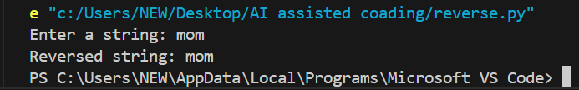

**Task Discription#3**

* **Generate a python program for Recursive and Iterate using with python function.**

**Expected Output#3**

* **Verify the expected output of the program.**

**Question**

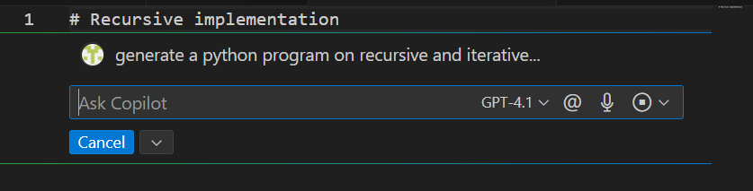

**Code**

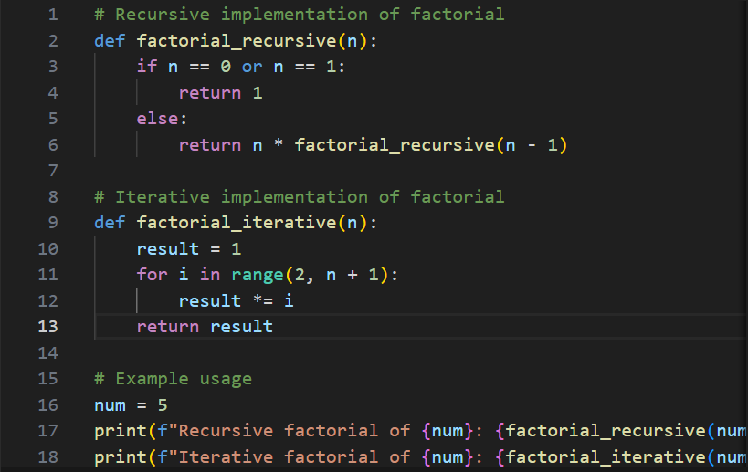

**Output**

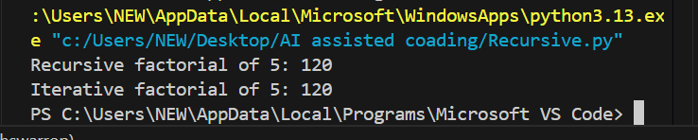

**Task Discription#4**

* **Generate the python program for finding the Largest number and assiss by the copilot.**

**Expected Output#4**

* **Verify the expected output and review of the code.**

**Question**

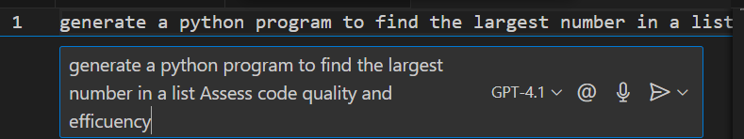

**Generated Code**

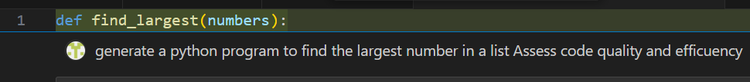

**Code**

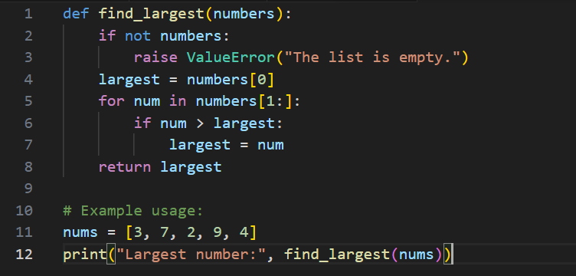

**Output**

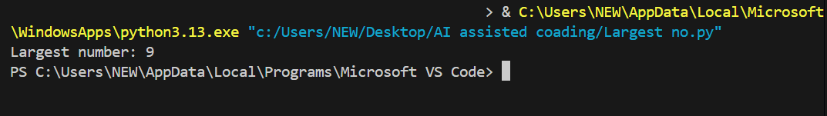

-------------------------------THE END--------------------------------------